1. 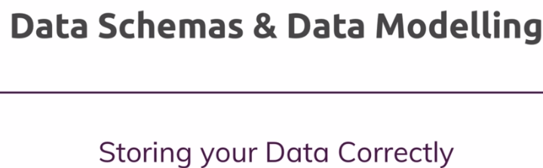
2. Let’s go back at the start of project where you have to decide about the followings
   1. How to model your data.
   2. How do we plan to store our data in the database?
   3. What relations exist b/w our data.
   4. How these relations are reflected in our database?
3. These are all important questions and these questions will impact us how we use mongodb and how we structure the data?
4. 